**Part 4: CRUD Operations – Hands-on Solution**

WEEK4_EXERCISE4_CRUD_Operations

Objectives

• Implement Update (PUT) and Delete (DELETE) in Web API.

• Test PUT and DELETE in Swagger UI.

• Test PUT and DELETE in Postman.

1. Update Controller Methods

// PUT /api/employee/{id}

[HttpPut("{id}")]

[ProducesResponseType(typeof(Employee), StatusCodes.Status200OK)]

[ProducesResponseType(StatusCodes.Status400BadRequest)]

public ActionResult<Employee> Put(int id, [FromBody] Employee updated)

{

if (id <= 0)

return BadRequest("Invalid employee id");

var list = GetStandardEmployeeList();

var emp = list.FirstOrDefault(e => e.Id == id);

if (emp == null)

return BadRequest("Invalid employee id");

// apply updates

emp.Name = updated.Name;

emp.Salary = updated.Salary;

emp.Permanent = updated.Permanent;

emp.Department = updated.Department;

emp.Skills = updated.Skills;

emp.DateOfBirth = updated.DateOfBirth;

return Ok(emp);

}

// DELETE /api/employee/{id}

[HttpDelete("{id}")]

[ProducesResponseType(StatusCodes.Status204NoContent)]

[ProducesResponseType(StatusCodes.Status400BadRequest)]

public IActionResult Delete(int id)

{

if (id <= 0)

return BadRequest("Invalid employee id");

var list = GetStandardEmployeeList();

var emp = list.FirstOrDefault(e => e.Id == id);

if (emp == null)

return BadRequest("Invalid employee id");

list.Remove(emp);

return NoContent();

}

Insert screenshot: 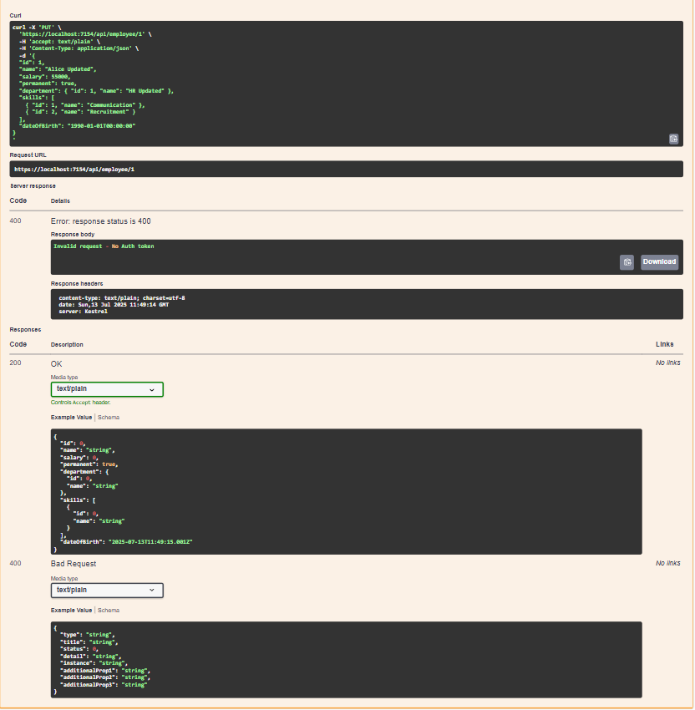

2. Testing in Swagger UI

* PUT

- Steps to Try it out…

- Verify 200 OK …



* DELETE

- Steps…

- Verify 204 No Content

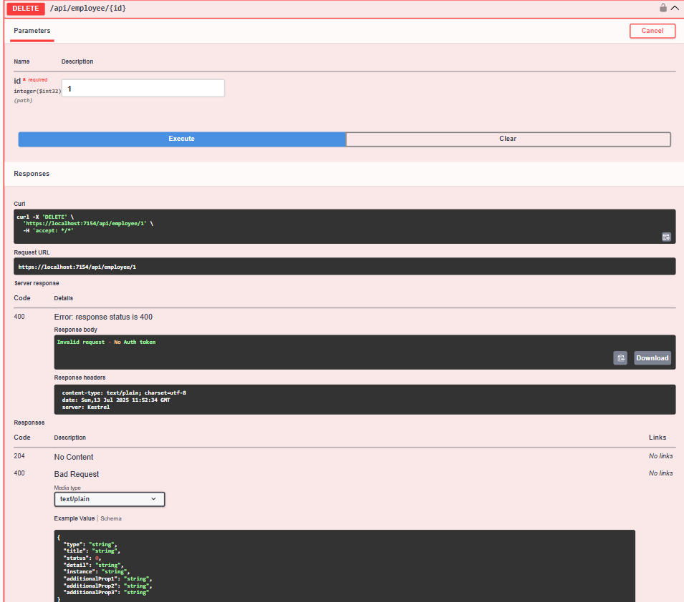

3. Testing in Postman

* PUT

- URL, headers, body…

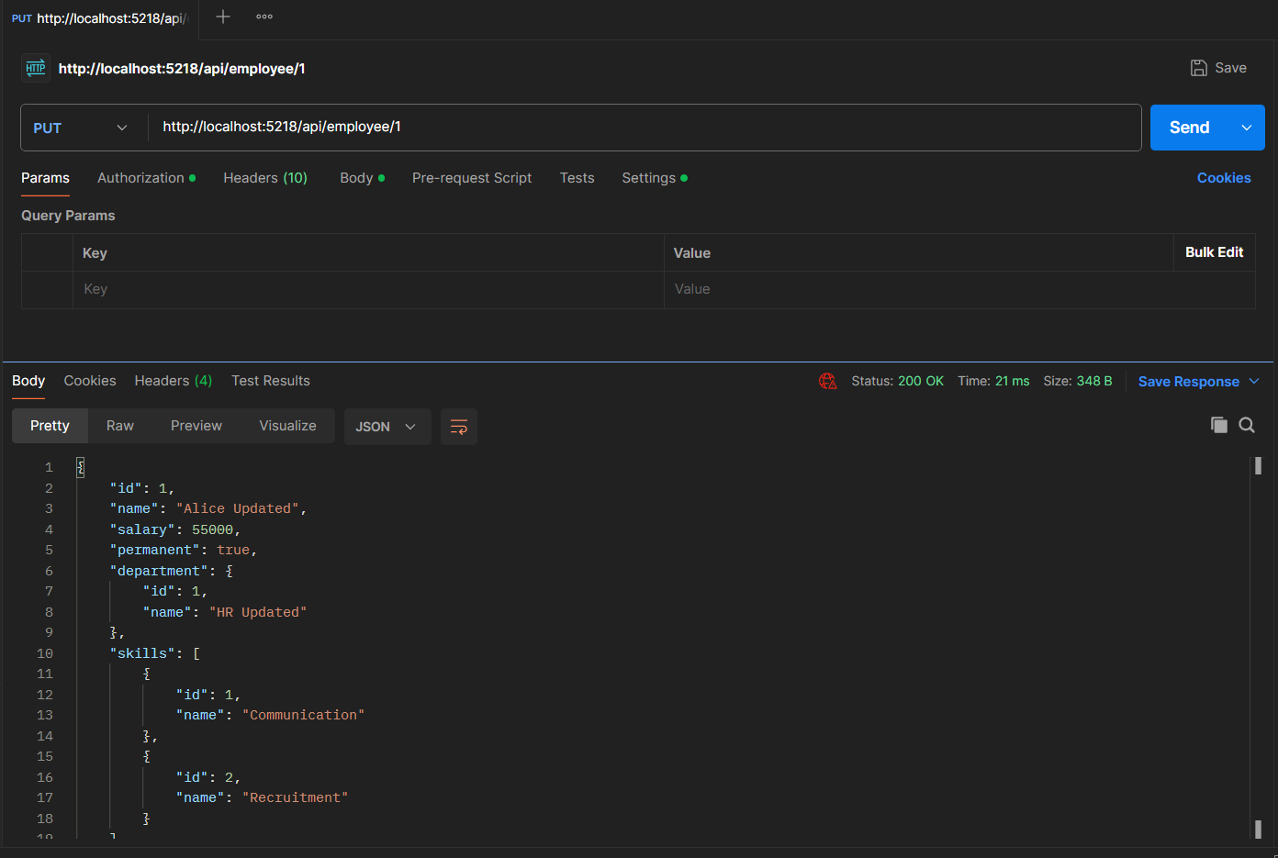

* DELETE

- URL…

